City's Homeless Count Tops 40,000
By MICHAEL HOWARD SAUL

NOVEMBER 9, 2011

The number of people in New York City's homeless-shelter population exceeded 40,000 last week for the first time, capping a rapid rise in homeless children and families since the spring when the city eliminated a rent subsidy program, according to a report to be released Wednesday.
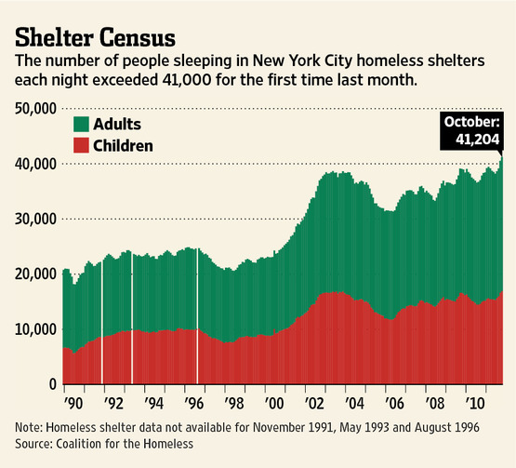
The report by the Coalition for the Homeless, an advocacy group, comes as Mayor Michael Bloomberg's administration faces renewed scrutiny for policies on homelessness that critics say have failed.

The City Council is slated Wednesday to hold a hearing on a new shelter-eligibility policy for single adults that Speaker Christine Quinn has denounced as "cruel" and "irresponsible."

"We are at a historic crisis of homelessness in the city," said Patrick Markee, senior policy analyst at the Coalition for the Homeless. "The numbers continue to rise and it is clear evidence of the failures of Mayor Bloomberg's approach to this problem."

The mayor's aides strongly defended on Tuesday the administration's approach to homelessness, but acknowledged the problem remains sizable and needs continued attention.

Mr. Bloomberg said earlier this year that he believes the shelter system is "infinitely better" than it was when he took office in January 2002.

According to an advance copy of the report provided to The Wall Street Journal, the shelter census on Halloween Night was 41,204, marking the first time it had exceeded 40,000 people.

The number of homeless children sleeping in municipal shelters—nearly 17,000—was also a record, said the report, which was based on city statistics.

Since May, children in shelters rose 10% and homeless families went up more than 5%, the report said.

Those increases followed the termination of a rent-subsidy program called Advantage for new participants, the report said.

"The numbers cited in the coalition's report are alarming, and clearly indicate the need to take a hard look at how the city is addressing the needs of homeless New Yorkers," said Ms. Quinn, a Manhattan Democrat and potential 2013 mayoral candidate. "At this point, the city must be using every available option to reverse this upward trend."

Seth Diamond, commissioner of the city's Department of Homeless Services, said the report doesn't fairly depict homelessness in the city.

He pointed to statistics showing family applications for shelter this summer were lower than any summer since 2008.

The number of families in city shelters in July, he said, was below 8,000 for the first time since October 2008.

Mr. Diamond acknowledged that the shelter population increases every summer, but he said this summer's increase was on the "low end" compared to previous summers.

The single adult numbers have increased recently, he said, "and we're certainly focused on that issue."

The commissioner said the city has the right emphasis on "accountability and self-sufficiency and moving people to work." Still, he said, "We have to do better—there are still too many families in the shelter system."

Mr. Bloomberg set a goal in 2004 of cutting both the number of people who sleep on the streets and use the shelter system by two-thirds by 2009, but neither pledge has been fulfilled.

In the spring, when the city lost state funding for Advantage, the administration immediately stopped admitting new participants. In September, a state judge ruled that the city can end the program for more than 30,000 people currently receiving subsidies. The ruling is on appeal.

Without the subsidy, advocates for the homeless say, thousands will return to the shelter system because they can't pay rent. Mr. Markee said if the courts allow the city to stop paying the subsidy "we'll see a wave of homelessness like we haven't seen in I don't know when."

Mr. Diamond said the coalition's "credibility" on Advantage has been tainted because it opposed the program and is now complaining about its demise. "It's ironic that they're for it after they were against it," he said.

Mr. Markee conceded he believes the Advantage program is "deeply flawed," but once it was eliminated, he said Mr. Bloomberg is the "first mayor since modern homelessness began who has no housing assistance program in place" to help families move from shelters into permanent housing.

Last week, the administration further enraged advocates for the homeless by announcing the city won't allow single adults into homeless shelters unless they demonstrate they have no other housing options.

Mr. Diamond said he believes it's a "responsible policy" to be able to ask people if they have alternatives.

The city plans to screen people in a "thoughtful" and "careful" way, he said.

"We think it's irresponsible not to ask people to explore alternatives first," he said.

Mr. Diamond said the administration is looking forward to explaining its stance to council members at Wednesday's hearing.

"It's a shame that people have gone out and demagogued this without hearing the details," he said.

Ms. Quinn said she believes the new screening policy will limit homeless single adults' access to shelters.

"Rather than telling people in need of housing to stay away, to truly reduce the homeless population we need proactive solutions such as restoring priority for the homeless for federal housing subsidies," she said.

